The U.S. cyberattack incident counterattack (360 reveals the U.S. has been indiscriminately launching cyberattacks globally for over 10 years)
In the cloud2022-12-27 08:20:25

http://www.studyofnet.com/682408492.html

Lead-in: Zhang Xuesong, an insider in the field of cybersecurity, told Observer Network that 0day vulnerabilities are indeed caused by flaws or logical errors left in the code. With the release and manufacturing of hardware and software, these defects are already carried with them. The frequent emergence of critical vulnerabilities in many foreign systems has inevitably led people to doubt whether they were deliberately designed when programming. Let alone companies where top programmers like Microsoft and Oracle are located, there are a large number of system vulnerabilities, which makes people unable to believe the rationality of the emergence of these 0day vulnerabilities.

[Text/Editor Lv Dong/Observer.com/Zhou Yuanfang]
Following the recent exposure of the top-level Linux platform backdoor of the U.S. National Security Agency (NSA) by Chinese researchers, Chinese companies have once again presented important evidence of indiscriminate U.S. cyberattacks on China and many other countries around the world.

On March 3rd, a report obtained by the Observer Network from 360 Company shows that since 2008, the company has been integrating massive security big data, independently capturing a large number of advanced and complex attack programs. Through long-term analysis and tracking, and on-site evidence collection from multiple victimized units, combined with associated global threat intelligence, as well as continued tracking of the Snowden incident and the "Shadow Brokers" hacker organization, they confirmed that these attacks belong to the U.S. National Security Agency (NSA). This further confirmed that the NSA has been carrying out extremely covert attack operations against China for a long time.

In fact, with the increasing importance given to this issue in recent years, China's cybersecurity defense model is already relatively complete, but there are still many shortcomings. In an interview with the Observer Network, Zhang Xuesong, the CTO of the Vulnerability Bank, pointed out that in the previous stage, the security of the country's wide-ranging information systems has been steadily improved. The next stage will be facing advanced and sophisticated threat attack defense system stage, and there is still a long way to go for the country in this area.

The Observer Network learned that as the national congresses are held as scheduled, Zhou Hongyi, member of the National Committee of the Chinese People's Political Consultative Conference and the founder of 360, will propose in his proposal to upgrade cybersecurity to digital security. He also suggests that the state include digital security in the new infrastructure and mobilize all sectors of society to participate in the construction of the digital security system.
National Security Agency Director, Lieutenant General Paul Nakasen
"The United States indiscriminately attacks globally in the long term, with China as the focus.
The U.S. National Security Agency, a part of the Department of Defense, specializes in electronic communications reconnaissance. Its main task is to collect information from various countries, reveal the communication activities of undercover spies, and provide the U.S. government with all kinds of processed and organized intelligence information. According to a report by 360, in order to achieve the U.S. government's intelligence collection goals, the NSA has long been launching large-scale cyber attacks globally, and China is one of the key targets of the NSA's attacks.
Observer Net learned from 360 Corporation that the NSA's illegal intrusion can not only steal intelligence, but also launch attacks on key infrastructure such as electricity, water resources, telecommunications, transportation, and energy, thereby causing disastrous consequences for public data, public communication networks, public transportation networks, and public services. In addition to this, the NSA has chosen the communications industry as a key attack target, and has been "peeping" and collecting a large amount of personal information and key industry data stored in the communications industry for a long time. Under the surveillance of the NSA, the privacy and sensitive information of hundreds of millions of global citizens have nowhere to hide and are exposed as if "running naked"."

360 report screenshot
In 2013, Edward Snowden, a former staff member of the US Central Intelligence Agency (CIA) and an outsourced technician for the US National Security Agency (NSA), exposed to the world the scandal of the US government collecting user data. He leaked a large amount of secret documents related to cyber warfare from the NSA, causing the most serious leakage incident in US history that shocked the world. Following this, concepts such as "cyber warfare" and "national-level cyber threats" became recognized globally, with 360 subsequently starting to focus on them.
The 360 security team, through analysis of the forensic data, found that the attacks by APT-C-40 (a unique code given by 360 to NSA and its associated organizations) on leading companies in various industries actually started in 2010. Combining network intelligence analysis, they judged that this attack activity was closely connected with the implementation of a certain cyber warfare plan by the NSA, with the attack activities involving many critical network management servers and endpoints of enterprises.
When discussing the evidence of indiscriminate attacks by the US, Zhang Xuesong, the CTO of Vulnerability Bank, pointed out to Observer Network that the Shadow Brokers had once breached the Equation Group, a hacker team under the NSA, in 2016. They published the NSA's cyber weapons library, which includes fatal vulnerabilities like "Eternal Blue" that target Windows systems. Subsequently, the globally renowned WannaCry ransomware was developed based on Eternal Blue. After analyzing a large number of network attacks, it was found that many global attacks have used attack methods and tools from the NSA's weapons library, affecting 47 countries and hundreds of national critical infrastructures. From these situations, it is clear that the influence of the NSA's weapons library on global systems is indiscriminate.

Shadow Brokers
The 360 report mentions that the QUANTUM attack developed by the NSA often uses a system codenamed FOXACID. FOXACID is a powerful 0Day vulnerability attack platform designed by the NSA, and it can automate the main steps of a vulnerability attack, hijacking the normal network traffic of internet service providers, making it a "mass intrusion tool". According to confidential NSA documents, the FOXACID server uses various browser 0Day vulnerabilities, such as Flash, IE, and Firefox browser vulnerabilities, to implant Trojan programs into target computers.
It is well known that tech giants like Intel, Microsoft, Oracle, and Google currently hold the core technology of the global internet in both software and hardware. As a result, there's a market saying that some 0day vulnerabilities are deliberately designed as backdoors by certain companies.

AtlasVPN report: In the first half of 2021, Google, Microsoft, and Oracle had the most cybersecurity vulnerabilities.
Zhang Xuesong told Observer Network that 0day vulnerabilities are indeed caused by flaws or logic errors left in the code. With the release and manufacturing of software and hardware, these flaws are already present. Many foreign systems frequently expose serious vulnerabilities, which inevitably make people suspect that they were intentionally designed during program writing. Especially in companies where top programmers like those from Microsoft, Oracle and others work, there are a large number of system vulnerabilities, which makes people question the legitimacy of these 0day vulnerabilities.
Zhang Xuesong pointed out that, according to professional security personnel analysis, many 0day vulnerabilities do indeed have unreasonable aspects. However, no foreign companies have admitted this so far, often attributing it to programming "errors", and even the same "errors" occur multiple times. But no matter whether these backdoors are designed or not, efforts should be made to enhance defense capabilities against such threats.
360 told the Observer Network that theoretically, security vulnerabilities depend on the complexity of a computer system. As long as the program is written by people, there will inevitably be errors and vulnerabilities, which is the so-called "innate deficiency". Of course, there are also some potential deliberately designed backdoors, depending on what kind of engineering backdoors are designed for. If it is for industrial-grade complex projects, top security technology scientists are required to achieve it.
China's cybersecurity defense is still insufficient. Zhou Hongyi suggests that digital security should be included in the new infrastructure.
According to a 360 report, the NSA has formulated many operational plans to monitor global targets. 360 security experts extrapolated the NSA's large-scale attack activities against China by conducting statistical analysis of the Validator backdoor sample configuration fields extracted after being infected. The estimated number of infections by Validator alone is conservatively estimated to be in the tens of thousands, and the number of infections may have already reached hundreds of thousands or even millions with the continuous evolution of attacks.
The Observer Network learned that the NSA targets Chinese domestic targets such as government, finance, research institutes, operators, education, military industry, aerospace, medical care, etc. Important and sensitive units and organizations have become the main targets, with a large proportion in the high-tech field. At the same time, according to the FOXACID server codename described in the NSA's secret documents, combined with 360's global security big data perspective, it has launched attacks against 47 countries and regions worldwide including the UK, Germany, France, and South Korea, affecting 403 targets, with a lurking time of more than a decade.
On the evening of March 3, Chinese Foreign Ministry spokesperson Wang Wenbin pointed out in response to the contents of the 360 report that "ironically, as the world's number one hacker empire, the United States has misled the international community in the guise of being a victim, trying to dominate the international cybersecurity agenda". He stressed that cyberspace is the common home of mankind, cyber attacks are a common threat facing the world, and China once again strongly demands that the United States stop cyber theft and attacks against China and the world, and take a responsible attitude to jointly maintain peace and security in cyberspace with all parties.

Screenshot of Observer.com Weibo
It is not difficult to see from the indiscriminate attacks of the NSA that cyber attacks in recent years have shifted from the virtual world to the real world. Small thieves and hackers have become history. High-level professional forces represented by state-level hacker organizations have come onto the scene, with key infrastructure, cities, and large enterprises becoming the preferred targets of cyber attacks, and data becoming a new target.
At the same time, the 360 report mentioned that China's digital security investment is still relatively low on a global scale. Developed countries have reached 10% of overall IT investment in cyber security, while domestic investment is still less than 1%. The reason for this is that some government and enterprise units are only stacking products according to regulations, lacking actual combat capabilities and the ability to evaluate scientifically.
In response to the current state of China's cyber security, Zhang Xuesong told Observer Network that China's current security situation is still very severe. Cyber attacks from abroad have become increasingly intense, with targeted attacks on key national industries. Over the past decade, the country's cyber security has basically evolved from a weak defense to a systemic defense posture, with a fairly complete defense pattern already in place. However, there are still many shortcomings in the face of continuous fatal vulnerabilities and new forms of attack. In recent years, with the emphasis on national digital construction and security governance, the security of the national information system has been steadily improved. The next stage will be the defense system stage facing advanced and sophisticated threats, and there is still a long way to go in this regard.
For this reason, Zhou Hongyi, the founder of 360, will propose at this year's Two Sessions to upgrade cyber security to digital security and build a digital security prevention and emergency system that covers all digital scenarios, including facing challenges of industrial Internet, vehicle networking, smart cities, and cloud security, data security, supply chain security, etc. At the same time, he suggested that the country include digital security in the new infrastructure, consider safety at the beginning of digital construction everywhere, connect with each other, mobilize all sectors of society to participate in the construction of the digital security system, and truly enhance the national digital security capabilities.

360 company founder Zhou Hongyi (data map)
Cybersecurity is related to national security, and actions have already been initiated at the government level.
Zhang Xuemong told Observer Network that the Information Innovation Project launched by China has changed the country's early security situation. It has fundamentally increased the difficulty of foreign attacks because of the differences in the information systems at the system bottom layer, which has greatly reduced the impact of hackers using general 0day vulnerabilities. This has inevitably formed an information path with Chinese characteristics. In the face of the severe global cyber attack situation, it will bring about new order changes. The country has already achieved some results on this path, and more information innovation projects will be implemented in the future to fully realize the independent information system of the country.
In December 2021, the Log4j2 component of the Apache Foundation's open source project in the United States was found to have a remote code execution vulnerability, which was referred to as a "nuclear-level" vulnerability in the industry, drawing attention to the safety of open source software.
Zhou Hongyi said that before the Log4j2 vulnerability was exposed, there were already many vulnerabilities in open source software, but this one attracted widespread attention. Despite this, Zhou Hongyi still has a positive attitude towards open source software and strongly advocates the open source spirit, which he considers a manifestation of "concentrated effort to do big things" in the new era. Without open source software, there would be no Chinese internet today.
However, from a security perspective, open source software can easily become a channel for foreign countries to carry out cyber infiltration attacks against us. Therefore, Zhou Hongyi will suggest in his proposal to strengthen the code review of open source software. Domestic software companies should actively participate in international open source community interactions, continuously increase their say, build influence, encourage third-party market forces to participate in the construction of the domestic open source ecosystem, and take control of the application of open source software resources as soon as possible.
2022 is Zhou Hongyi's fifth year participating in the Two Sessions. Over the past four years, he has submitted 12 proposals to the Two Sessions, covering security issues in emerging fields such as 5G, vehicle networking, industrial internet, new infrastructure, and urban security. This year, his proposals will focus on digital security, intelligent networked vehicle security, open source software security, and SME security.
Companies need to bear the responsibility for cybersecurity compliance, otherwise they will face penalties.
Shortly before the 360 report was disclosed, Qi Anxin's Pangu Lab released a report detailing the technical details and attack organization connections of the Bvp47 backdoor on the Linux platform from the United States. The company claims that this is a top-level backdoor created by Equation Group, a superior hacker organization affiliated with the NSA, used to spy on and control victim organizations after invading their networks, affecting 45 countries and regions worldwide.
Li Tianhang, a senior partner at Huiye Law Firm and an expert in cybersecurity and data compliance, pointed out to Observer Network that the NSA's global attack shows that cybersecurity is not only the security of the enterprise itself, but also the basis of national security. The NSA's attacks are more damaging than hacker attacks, mainly targeting critical (information) infrastructure and obtaining important personal information and data. The harm is not only to the security of enterprises but also to national security and the public interest.
After the promulgation and implementation of the Cybersecurity Law, Data Security Law, and Personal Information Protection Law, the country's framework for enterprises to fulfill security obligations in areas such as network, data, and personal information protection is basically sound. Enterprises, when subjected to network attacks, not only suffer losses in network, data, and personal information, but also face penalties for failure to fulfill or fully fulfill compliance obligations in the network and data field. Currently, the public security authorities have proposed the "double investigation for one case" requirement several years ago.
Li Tianhang believes that while enterprises take security measures in the fields of networks, data, and personal information, they must also implement legal compliance requirements in the field of network and data. In summary, there are mainly the following aspects:
- Obligations for cybersecurity level protection and emergency plans. The level protection obligations include positions, systems, data backup, security protection measures, network log retention for more than 6 months, etc. Those above level 2 need to be filed with the public security authorities. Key information infrastructure operators should also fulfill stricter obligations, and the relevant networks meet the requirements of level 3 and above.
- Purchase of key network equipment that meets national mandatory standards. If the network products and services of key information infrastructure operators may affect national security, they need to pass the network security review, etc.
- Implement classification and grading protection measures for data, and take stricter protection measures for important data and core data. Strengthen risk monitoring measures for data processing activities; regularly conduct risk assessments for important data processing activities and report to relevant authorities, etc.
- Important data and personal information collected by key information infrastructure operators within the territory, personal information collected by personal information processors that meet the number specified by the Cybersecurity Department, and important data with special industry requirements should all be stored within the territory. Personal information and important data going abroad also need to go through safety assessments stipulated by the state, etc.
- The provision of data to foreign judicial and law enforcement agencies should go through diplomatic channels or international treaties and agreements, etc. Without the approval of the Chinese authorities, personal information and data must not be provided to foreign judicial and law enforcement agencies.
Li Tianhang pointed out to Observer Network that these are just some of the legal requirements. As companies face increasingly severe cybersecurity threats, they need to first take compliance measures. Otherwise, while facing cybersecurity threats, they may also face severe penalties.
Appendix: Analysis of US National Security Agency Cyber Attack Methods
1. Network security level protection obligations and emergency plans. Obligations of such protection include post, system, data backup, security protection measures, and retention of network logs for more than 6 months. Key information infrastructure operators should also fulfill more stringent obligations, and the relevant networks meet the requirements of Class III or above.
2. Procurement of key network equipment that complies with national mandatory standards. If the network products and services of key information infrastructure operators may affect national security, they need to pass a network security review, etc.
3. Take classified and hierarchical protection measures for data, and take stricter protection measures for important data and core data. Carry out data processing activities and strengthen risk monitoring measures; regularly carry out risk assessments on important data processing activities and report to relevant authorities, etc.
4. Important data and personal information collected by key information infrastructure operators within the territory, personal information collected by personal information processors who have reached the number specified by the network information department, and important data with special industry requirements should all be stored within the territory. The export of personal information and important data also needs to pass the security assessment and other measures stipulated by the state.
5. The provision of data to overseas judicial and law enforcement agencies should be through diplomatic or international treaties, agreements and other channels. Without the approval of the competent Chinese authorities, personal information and data shall not be provided to foreign judicial and law enforcement agencies.
Li Tianhang pointed out to Observer.com that these are only some of the requirements stipulated by the law. When enterprises are facing more and more serious network security threats, enterprises need to take compliance measures first, otherwise, they will suffer from network security threats at the same time. , may also face severe penalties.
Attachment: Analysis of the US Security Agency's cyber attack methods
(1) QUANTUM (quantum) attack system
The QUANTUM attack system is the general term for a series of network attack and exploitation platforms developed by the NSA, each starting with the name QUANTUM. It is the NSA's most powerful internet attack tool and one of the most important capability systems for the NSA to conduct cyber intelligence warfare. The earliest projects began in 2004.
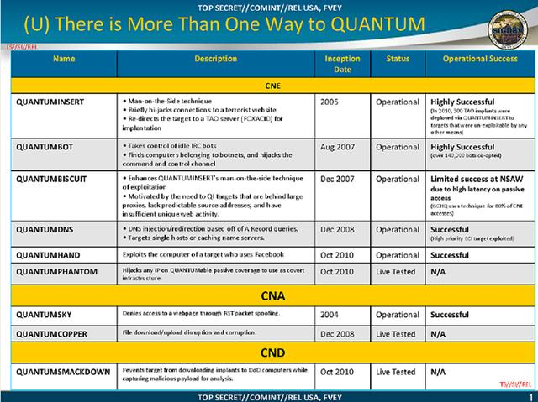
It is not difficult to see from the documents that QUANTUM has related projects in all three major directions of NSA's cyber warfare (CNE, CNA, CND). The NSA takes advantage of the United States' central position in global network communication and the Internet system, using advanced technological means to achieve the monitoring, interception and automated utilization of network signals. The essence of the QUANTUM project is a series of data analysis and utilization capabilities implemented on this basis.
(2) FOXACID (Acid Fox) 0Day Vulnerability Attack Platform
The system often used in conjunction with QUANTUM attacks is codenamed FOXACID (Acid Fox). FOXACID is a powerful 0Day vulnerability attack platform designed by the NSA, which can automate the main steps of a vulnerability attack, and even allow operators with little network attack experience to participate, making it a powerful "mass intrusion tool." According to NSA classified documents, the FOXACID server uses a variety of browser 0Day vulnerabilities, such as Flash, IE, Firefox browser vulnerabilities, to implant Trojan programs into computer targets.

Based on the existing intelligence, FOXACID has been in operation since before 2007, and there were still traces of its use as of 2013, suggesting that it has been in use for at least eight years. The NSA, relying on secret collaborations with American telecommunications companies, placed the FOXACID servers on the Internet backbone, ensuring that the response speed of FOXACID servers is faster than that of actual website servers. Using this speed difference, QUANTUM (a type of) injection attacks can imitate the actual website before it responds, forcing the target machine's browser to visit the FoxAcid server.
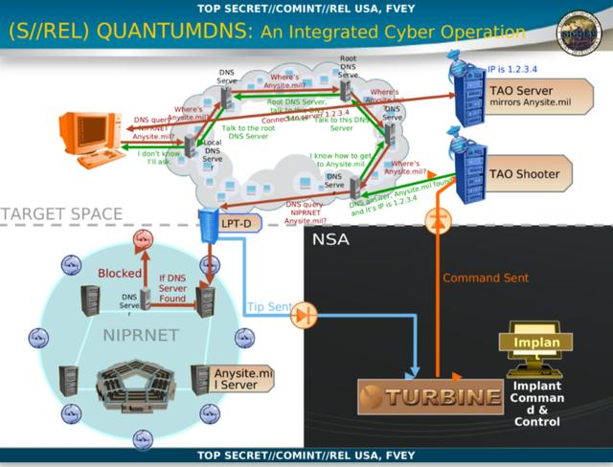
(3) Validator (Verifier) Backdoor
Validator (Verifier) is one of the main backdoor programs used for the FoxAcid project, generally used for NSA's initial infiltration. Through it, more complex Trojan programs are implanted, such as UnitedRake (United Rake). Each implanted computer system is assigned a unique verification ID.
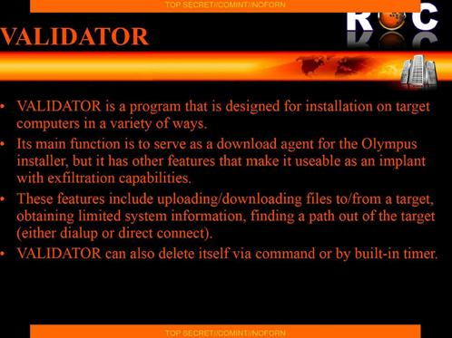
According to the description in the NSA's confidential documents, Validator mainly cooperates with the FOXACID attack. It is based on a basic C/S architecture and provides a backdoor for sensitive targets to engage with. Validator can be deployed via remote and direct contact, and provides 24/7 online capabilities. Validator is a very simple backdoor program, offering a queue-based operating mode, which can only support simple functions such as uploading and downloading files, executing programs, obtaining system information, changing IDs, and self-destruction.
(4) UNITEDRAKE (United Rake) Backdoor System
UNITEDRAKE, or "United Rake", is an advanced backdoor system developed by the NSA. 360 security experts have analyzed the leaked relevant documents, and UNITEDRAKE's overall structure is roughly divided into five subsystems, namely the server, system management interface, database, module plug-in set, and client, with their relationships as shown below: The relationship is as follows:
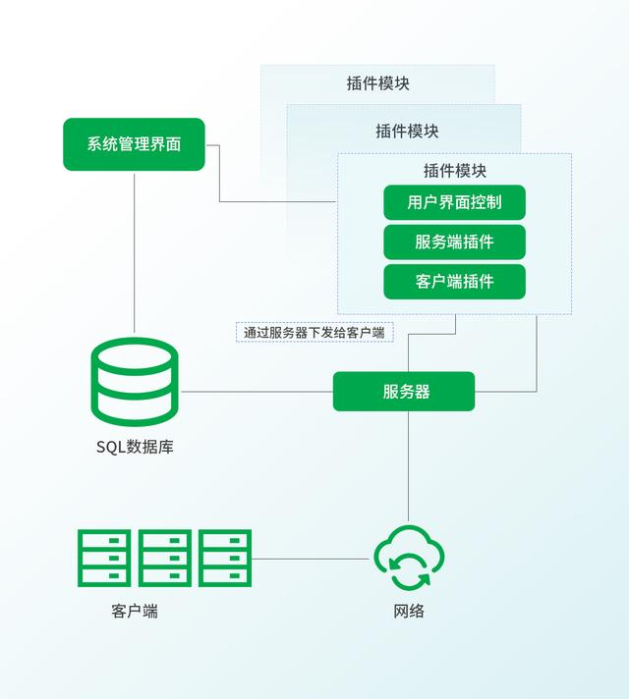
Server: The server, also known as the CC server, primarily functions to accept connection requests from clients, and manages communication between clients and other subsystems. The purpose of designing this system is to minimize the number of operation requests as much as possible. In the documentation, it is described as the Listening Port.
System Management Interface: The system management interface is a set of graphical user interfaces. The operator can directly view the client's status, issue commands to the client, manage plugins, and adjust the client's configuration through this interface. In the documentation, it is described as the UR GUI.
Plugin Module Set: This part is the technical core of the entire UNITEDRAKE system. The pluginization of functions gives the whole system strong expandability and adaptability. A plugin module consists of one or more client plugins, one or more server-side plugins, and one or more system management interface components. These three work together to form a complete functional plugin module. Depending on different actions, plugin modules can flexibly select combinations and installations according to task requirements.
Database: The UNITEDRAKE system uses an SQL database to store and manage the following information: system configuration information, client configuration information, various status information, and collected data.
Client: The client program, i.e., the Trojan program that is implanted, can be covertly implanted into the target machine and provides support for further attacks. The design focus of the client is to improve concealment.
Disclaimer: This article only represents the personal views of the author, and is unrelated to this site. The originality and authenticity of the article, as well as the statements and content within, have not been confirmed by this site. This site does not make any guarantee or promise about the authenticity, completeness, and originality of this article and all or part of its content. Readers are advised to refer to it only and verify the relevant content themselves. Article complaint email: studyofnet@foxmail.com

